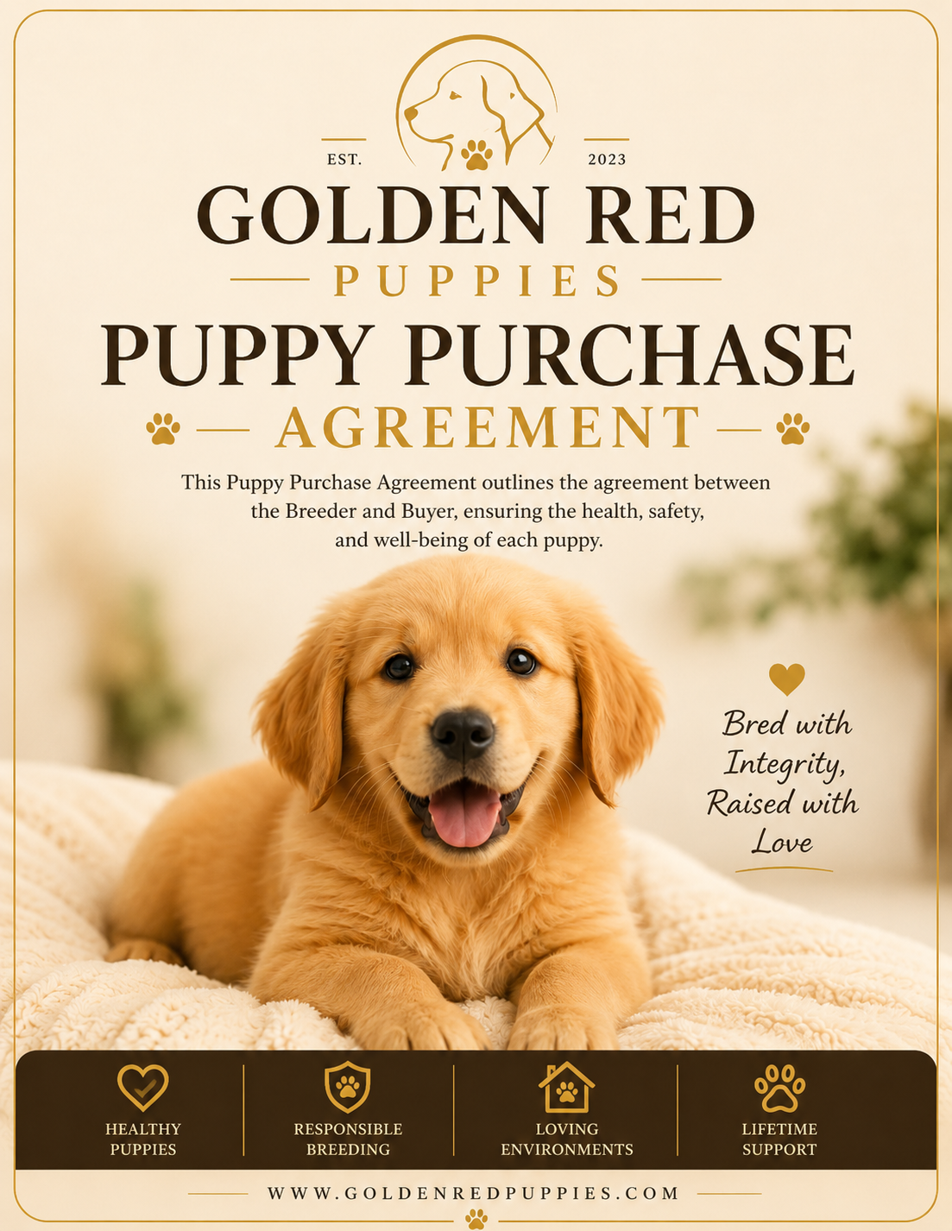

🐾 Puppy Purchase Contract

This Puppy Purchase Contract outlines the agreement between the Breeder and Buyer, ensuring the health, safety, and well-being of each puppy. Full legal terms apply.

Agreement
This Puppy Purchase Contract is entered into on __________________ between Michelle Costello (Breeder), doing business as Golden Red Puppies, and ____________________________________________________ (Buyer).

Breeder Information
Name: Michelle Costello
Business: Golden Red Puppies
Address: 3217 Foxden Lane Plant City, FL 33565
Phone:508-317-3113 Email: macostello01@yahoo.com
Website: www.goldenredpuppies.com

Buyer Information
Name: ________________________________________________
Co-Buyer: ____________________________________________
Address: ______________________________________________
City/State/ZIP: _______________________________________
Phone: _________________________________________________
Email: __________________________________________________

1. Puppy Information
- Breed: Golden Retriever
- Sex: ☐ Male ☐ Female
- Date of Birth: _____________________________
- Color/Markings: _________________________
- Microchip: ________________________________

2. Purchase Price & Deposit
- Total Purchase Price: $___________________
- Non-Refundable Deposit: $500 (applied toward total purchase price)
- Remaining Balance Due: $________________ (due prior to or at pickup/delivery)
- Deposit terms as outlined in the Deposit Agreement section of this Contract.

3. Health & Veterinary Care
- Puppy will receive a veterinary health exam prior to transfer.
- Puppy will be up-to-date on vaccinations and deworming.
- Breeder will provide a health certificate.
- Buyer must take the Puppy to a licensed veterinarian within 72 hours of receipt for a wellness check.

4. Refund Policy

$500 Non-Refundable Deposit
- All deposits made to reserve a Puppy are non-refundable under any circumstances. Deposits may, however, be transferred to a future litter at the Breeder’s discretion.

Refunds Prior to Transfer
- If the Puppy becomes unavailable due to illness, injury, or death while in the care of the Breeder prior to transfer, the Buyer will be entitled to a full refund of all monies paid, including the deposit, or may choose to apply funds to another available Puppy or future litter.

Refunds After Transfer
- Once the Puppy has been delivered to or picked up by the Buyer, all sales are final.
- Refunds will not be issued for reasons including, but not limited to, change of mind, allergies, landlord restrictions, incompatibility with other pets, or Buyer’s personal circumstances, unless otherwise agreed upon by Breeder and Buyer.

Health Guarantee Exception
- If the Puppy is diagnosed by a licensed veterinarian with a life-threatening congenital defect within the health guarantee period outlined in this Agreement, the Buyer must notify the Breeder in writing within 72 hours and provide veterinary documentation.
- In such case, the Breeder will, at the Breeder’s sole discretion:
- a. Offer a replacement Puppy of equal value from the next available litter, OR
- b. Issue a partial or full refund (excluding deposit), based on veterinary findings and the return of the Puppy to the Breeder.

5. Return Policy
- If at any time the Buyer is unable to keep the Puppy, the Puppy must be returned to the Breeder.
- No refunds will be given, unless otherwise agreed upon in writing by the Breeder and Buyer. The Breeder will assist in rehoming the Puppy.
- The Buyer agrees never to surrender the Puppy to a shelter, rescue, or third-party rehoming service and to call the Breeder first.

6. Buyer Responsibilities
- Provide proper veterinary care, vaccinations, and preventative health treatments.
- Provide adequate food, water, shelter, and companionship.
- Never use the Puppy for neglectful or inhumane purposes (e.g., dog fighting, puppy mills).

7. Shipping Policy
- All shipping arrangements must be coordinated directly with the Breeder prior to the Puppy’s departure.
- Puppies must be at least 8 weeks old before traveling.
- Each Puppy will receive a health certificate from a licensed veterinarian.
- Puppies are up to date on vaccinations and deworming prior to shipping.
- Puppies are shipped in an airline-approved crate that is theirs to keep.
- Shipping may be delayed due to extreme weather or hazardous conditions.
- Buyer is responsible for all shipping costs, including airfare/transport fees.
- Once the Puppy is delivered to the airline or transport company designated for shipment, the risk of loss transfers to the Buyer.

8. Final Agreement
This agreement is legally binding and enforceable. Both parties acknowledge that they have read, understood, and agreed to the terms of this Puppy Purchase Contract.

9. Buyer Acknowledgments
☐ Received vaccination records.
☐ Received deworming records.
☐ Received microchip information (if applicable).
☐ Inspected Puppy and accepts its condition.
☐ Read and understood this Agreement.

Signatures
BREEDER
Signature: ____________________________
Printed Name: Michelle Costello
Date: _________________________________
BUYER
Signature: ______________________________
Printed Name: _________________________
Date: ___________________________________

Golden Red Puppies

───────────────────────────────────────🐾
Bred with Integrity, Raised with Love
www.goldenredpuppies.com

